WSUS on Windows Core

# Liste commande

## Windows Update Overview

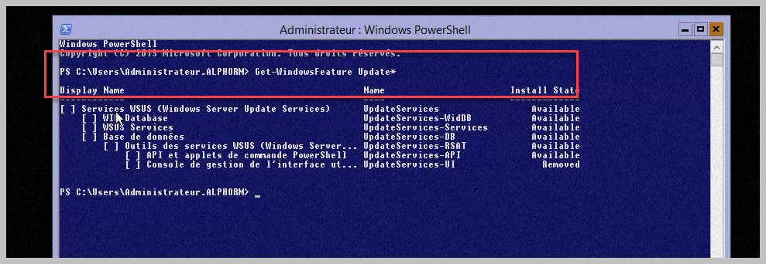

## Installing Windows Update Tools

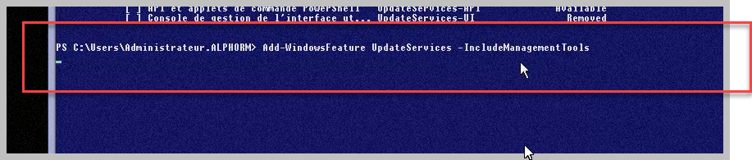

# Rappel diskpart

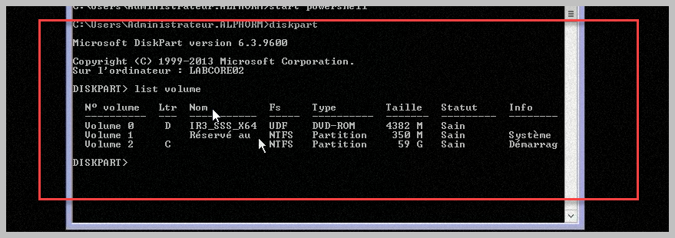

## Selecting Volume

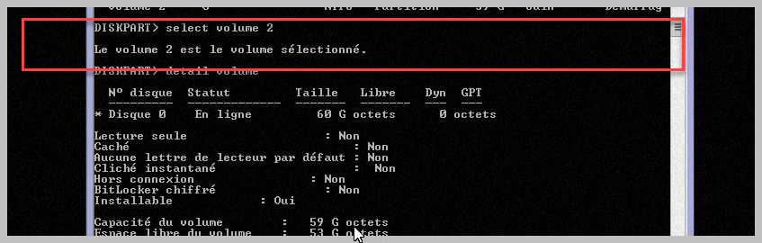

## Shrink the selected volume

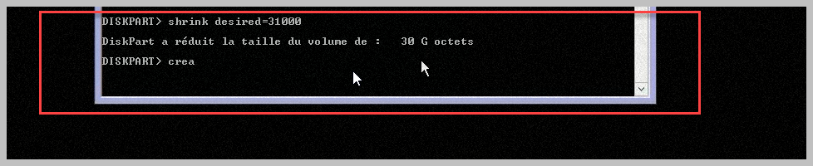

## Create Partition to the prepare the Wsus storage

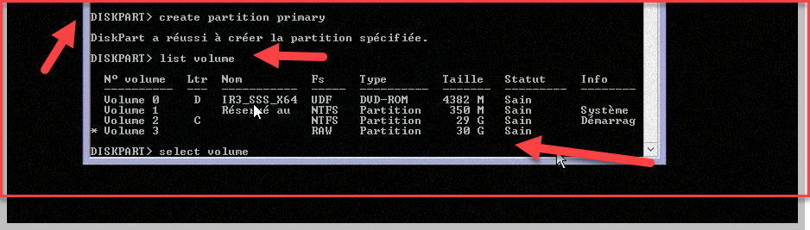

## Formatting the disk

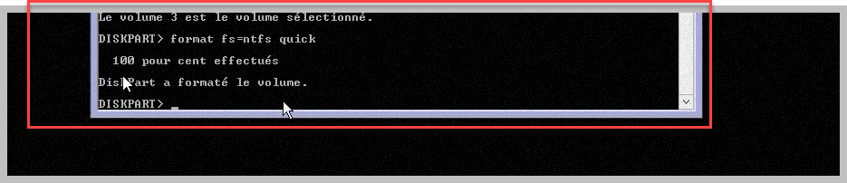

## Overview of Volume

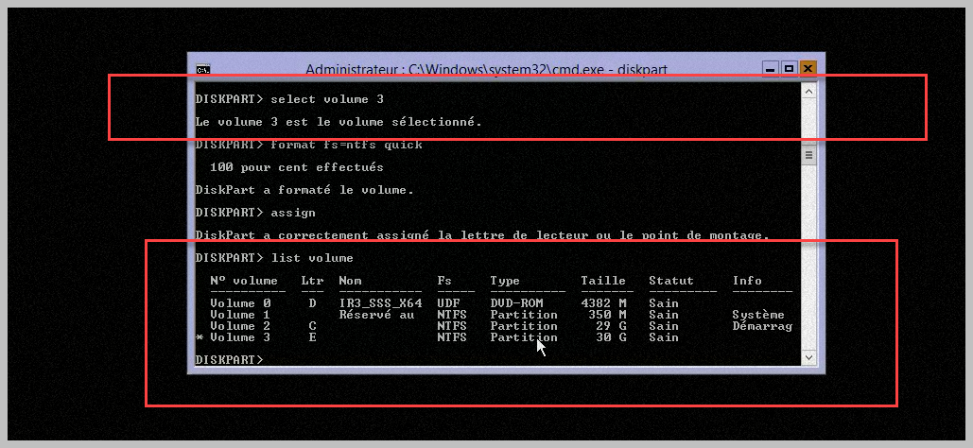

# Wsus Configuration

## Prepare the folder

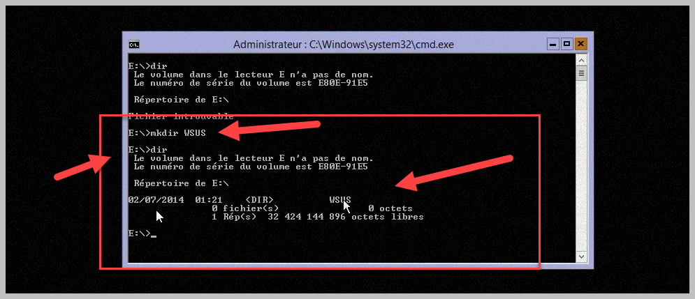

## Starting the installation of wsus

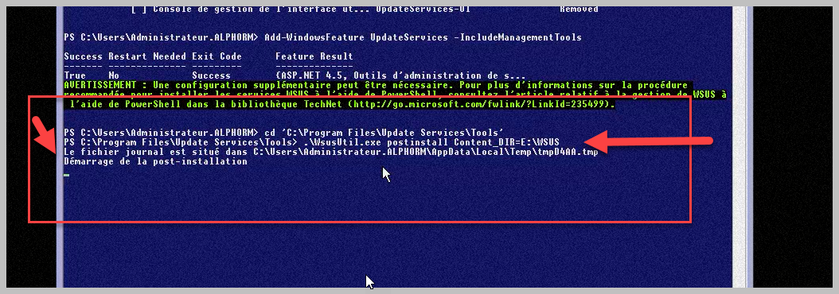

## Overview du service

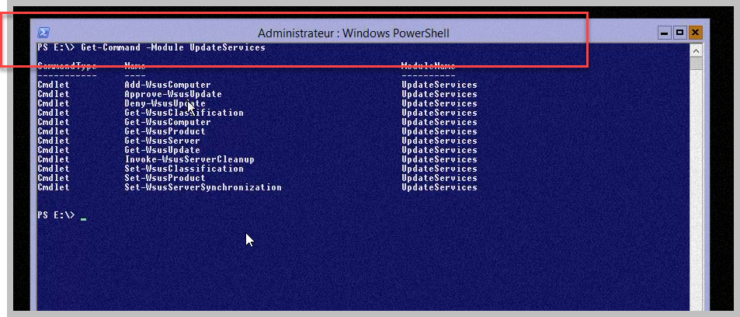

## Overview list of Module

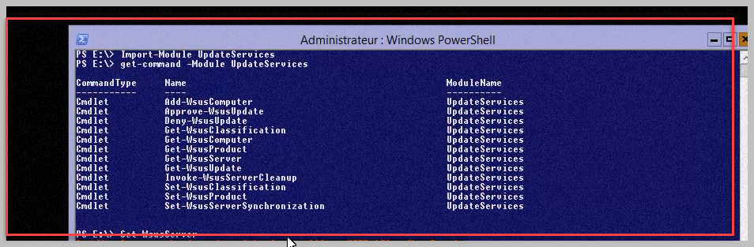

## Overview of Helping

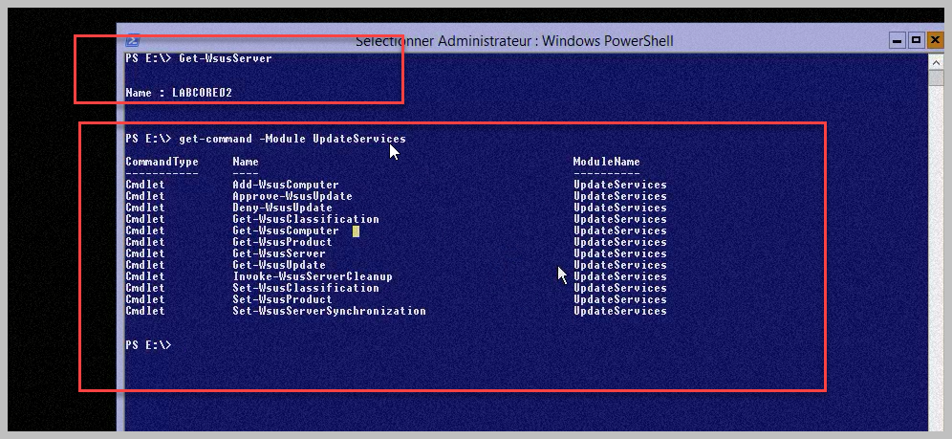

## Getting WSUS Configuration

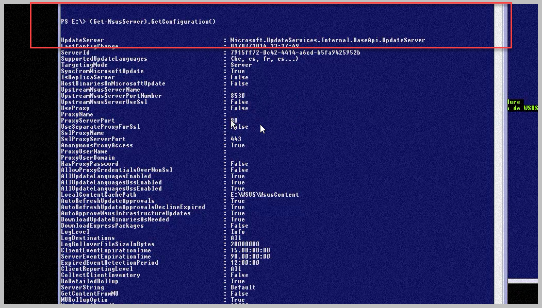

## Setting WSUS Synchronisation

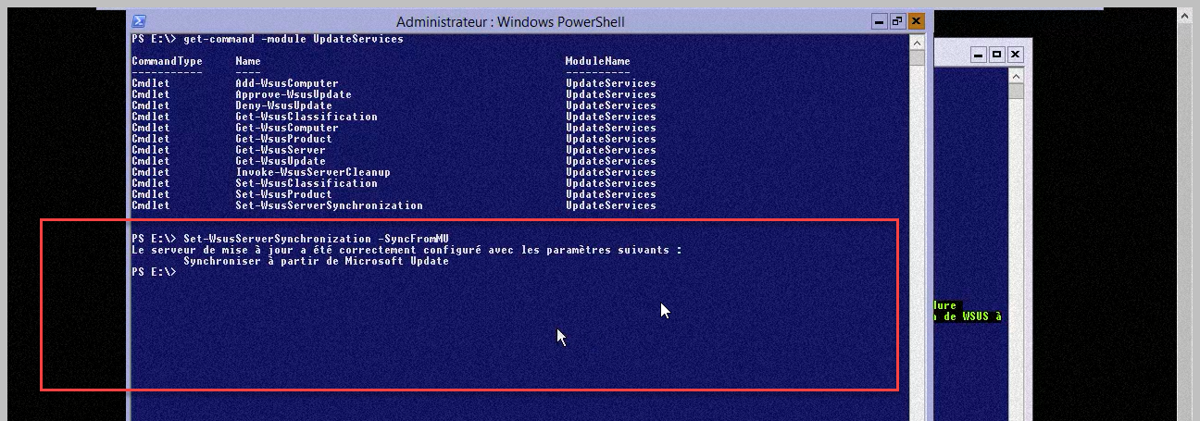

# Quelques autres commandes

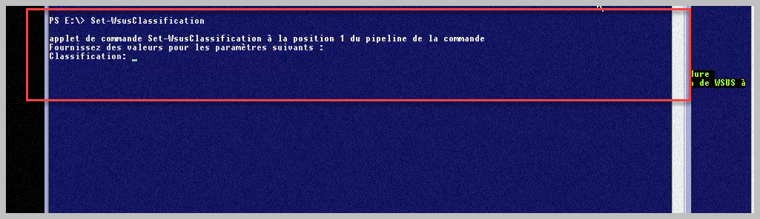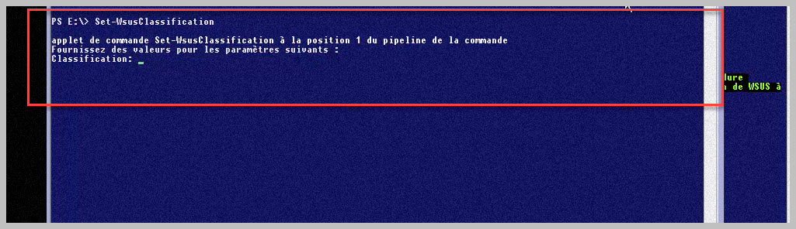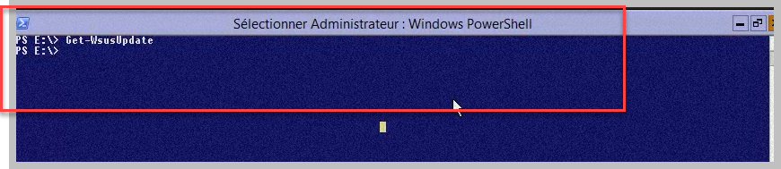

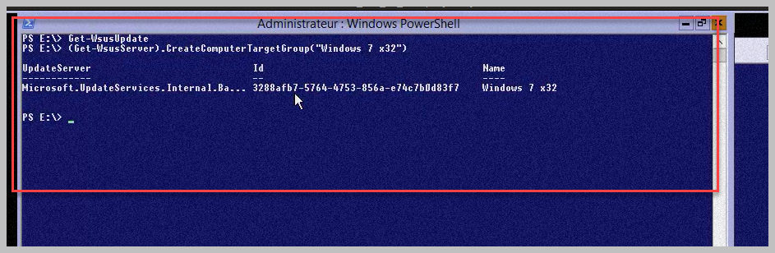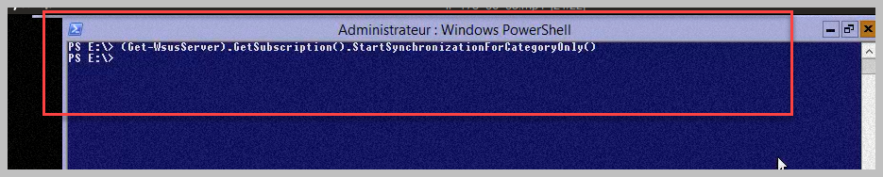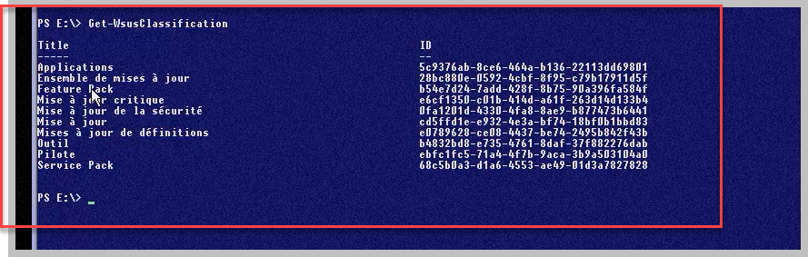

# Close

